EXPERIMENT- 32
Morphological Operations using Closing Technique
Aim
To write a Python code to perform Morphological Closing operation on an image using OpenCV for filling small holes in the image.
Input Image
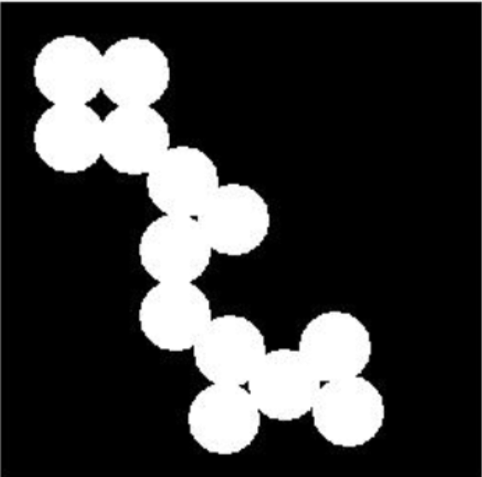
Code
from google.colab import files
import cv2
import numpy as np
from google.colab.patches import cv2_imshow
uploaded = files.upload()
image_path = list(uploaded.keys())[0]
image = cv2.imread(image_path, cv2.IMREAD_GRAYSCALE)
kernel = np.ones((5,5), np.uint8)
closing = cv2.morphologyEx(image, cv2.MORPH_CLOSE, kernel)
cv2_imshow(image)
cv2_imshow(closing)
Output Image
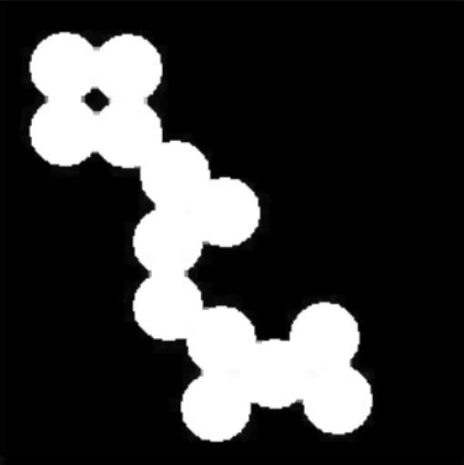
Result
Thus, the morphological closing operation was successfully performed using OpenCV.

